Lisa A. Cudahy
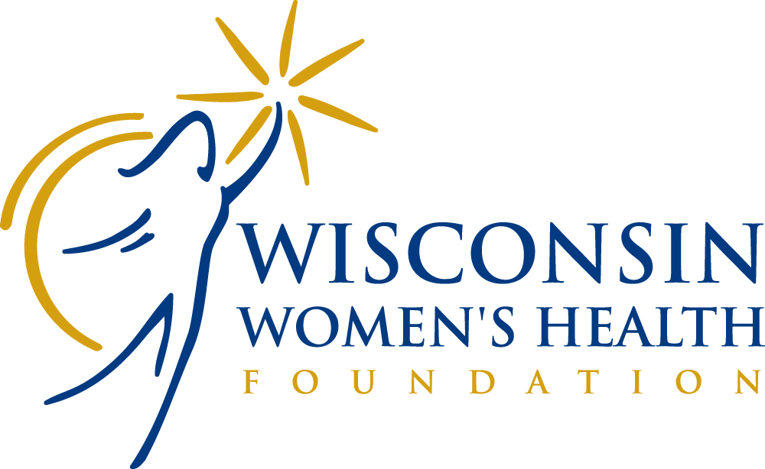

2023 Community Health Grant Guidelines
Wisconsin Women’s Health Foundation
Application Deadline: January 13, 2023

Organization Overview
The Wisconsin Women’s Health Foundation (WWHF) is a nonprofit organization that provides health services and education for Wisconsin women and their families. WWHF has 3 programs covering all 72 Wisconsin counties, serving over 7,000 women each year.

WWHF services and research initiatives are rooted in evidence-based prevention of the diseases and conditions that most impact Wisconsin women’s wellness. The Foundation’s mission is to innovate, impact, and improve women’s health.

Lisa A. Cudahy Community Health Grant
Through the Lisa A. Cudahy Community Health Grants, WWHF strives to promote and assist nonprofit community organizations committed to education and outreach in women’s health. These grants are awarded every two years.

We partner with local nonprofit organizations looking to pilot and/or expand innovative and impactful women’s health programming. These grants are based on the premise that partnerships between WWHF and local, nonprofit community organizations capitalize on the strengths and unique skills of each organization.

Grant Amount: Up to $2,000
Eligibility
Nonprofit organizations in Wisconsin with a IRS 501(c)(3) designation may apply for a grant.

Program Priorities
Priority will be given to projects aligned with WWHF’s targeted topics (cancer, cardiovascular disease, domestic abuse, mental illness, osteoporosis, prenatal/perinatal issues, tobacco cessation, and substance exposed pregnancies). WWHF seeks diversity, geographic as well as underserved populations, when considering application requests.

The following types of projects will not be funded:
- advertising
- capital campaigns
- fundraising activities (including tables, tickets, dinners, walks, sporting events, etc.)
- grants or scholarships to individuals
- multi-year requests
- political causes or events
- religious organizations in support of their sacramental or theological functions

To Submit an Application
- Please read all instructions prior to submitting your application.
- Email is the preferred method for application submission in either Microsoft Word or PDF format to nmiller@wwhf.org. Applicants that do not have email may submit applications via mail to Wisconsin Women’s Health Foundation, Attn: Nora Miller, 2503 Todd Drive, Madison, WI 53713 or via fax at 608-251-4136.
- A confirmation of your submission should be received in three days. If you do not receive a confirmation, please call Nora Miller at 608-251-1675 or 800-448-5148, Ext. 103.
Application Submission Deadline
Applications must be received by January 13, 2023.
Funding Notification
This is a competitive process. All applications will be evaluated by a review panel. Applicants will be notified in writing as to the status of their application by March 1, 2023. WWHF does not provide individual feedback on applications.
For help with this Application:
Email nmiller@wwhf.org or call 608-251-1675 or 800-448-5148, Ext. 103.

APPLICATION GUIDELINES
Completed applications cannot exceed 8 pages in length (including budget and cover page) and must include the following:
Cover Page
- Signed by an official from your organization with fiduciary responsibility.
Organizational Background Information
- Description of organization’s mission and services
- Description of geographic area and target population
- Number of individuals served annually
- Annual Operating Budget Total
- 501(c)3 official documentation (This is not counted as part of the 8 pages)
Proposed Project Description
- Project Title
- Project goals and relation to WWHF priority areas (listed on page 2)
- Community need for the project
- Target population
- Work plan/timeline
- Key activities and deliverables
- Proposed project partners and history of collaboration
Project Evaluation
- Include up to 3 Project Objectives with Performance Measures
Project Budget
- Provide a detailed budget
- Grant funds may be used to support printing, postage, venue, food costs, speaker fees, posters, conference brochures, and other direct expenses of carrying out the activities of the proposed initiative.
- Grant funds may not be used to subsidize individuals directly for the cost of attending the event, or for salaries.

Review Process
Applications will be evaluated by a review panel using the following criteria:
- Cover Page (5 points)
- Organizational Background (20 points)
- Proposed Project Description (45 points)
- Project Evaluation (15 points)
- Budget (15 points)
Program Guidelines
- The number of grants and total dollars awarded will depend upon the quantity and quality of applications received and availability of resources. Grant requests up to $2,000 will be considered. Grants will not necessarily be awarded at the full amount requested. Submission of an application is not a guarantee of funding.
- Organizations may submit only one application.
- Proposals will be evaluated based on criteria met and potential for impact.
- Proposals are accepted via email, fax and mail. We encourage early submission to avoid last-minute submission problems. We are unable to grant extensions to stated deadline for any reason.
- We are unable to respond to inquiries about a proposal's status during the review period.
- Organizations awarded a grant will be required to file a follow-up report.

WWHF asks that it be recognized in promotional materials, radio/television interviews, conference brochures, announcements during the event, and that complimentary exhibit space be provided, if applicable.

Project Time Frame
Awardees will have until December 31, 2023 to complete their projects and until January 31, 2024 to submit their final report.

Lisa A. Cudahy Community Health Grant

2023 Application

Cover Page

Contact Information

Organization Name:
Mailing Address, City, State, Zip:
Website:
President/CEO/Executive Director:
Project Contact Person:
Telephone Number:
Email Address:
Fax Number:
Organization’s Employer Identification Number (EIN)/Tax Exempt Number:
Printed name of responsible official:
Signature of responsible official:
Date Signed:

Note: Applications should be signed by an official with fiduciary responsibility for your organization. For applications submitted via email, a typed signature with a statement “this typed signature represents an official signature” is acceptable.

