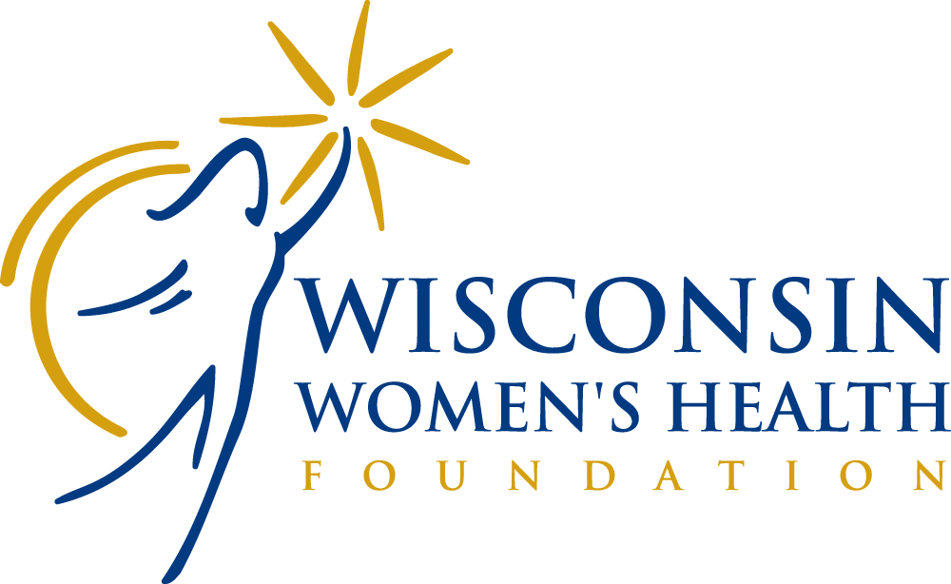

Markos Family Breast Cancer Woman Faculty Scholar
2022 Grant Application

Goal

This award is given by the Wisconsin Women’s Health Foundation (WWHF) to a junior woman faculty member (assistant professor or assistant scientist) to support her development as a leader in breast cancer research. This support provides the opportunity for more women to reach leadership positions where they can introduce women-centered concepts into the training of health care professionals, influence health policy to eliminate gender bias, and contribute to scientific knowledge which should underlie health care practices related to women. This award is limited to women until gender equity is achieved in academic medicine.

Amount

The amount of the award is determined by WWHF. The award for the current year is $20,000.

Eligible Candidates

Any woman junior faculty member in Wisconsin in the health profession, life sciences, biomedical sciences, or social sciences is eligible. Priority will be given to women whose work is directly relevant to advancing breast cancer research and who display leadership potential.

The proposed research must follow the National Institutes of Health (NIH) guidelines in terms of inclusion of women and minority subjects in research.

Application/Submission Information and Conditions of the Grant
The media and eligible institutions will be notified of the competition for WWHF’s research grants. Applications are available on WWHF’s website, www.wwhf.org or can be requested via phone at 608-251-1675, ext. 103.

The application deadline is September 2, 2022.

All applications must be submitted via e-mail to nmiller@wwhf.org.

A completed application must include the following components arranged in the following order:

- Applicant Information Page (Page 3 of this application)
- Biosketches for key personnel: Attach a biosketch or curriculum vitae (NIH biosketch form preferred); a statement of past, current, and pending research funding; and a description of other funding (NIH format).
- Budget: State how the funds will be used. Please provide justification for any direct expenses.
- Description of proposed research: (No more than 10 pages, excluding literature cited, 1.0” margins, and single-spaced using font face Arial, 11-point.) Include within the 10 pages an abstract (< 300 words), a one-page personal statement including a leadership development plan, specific aims, background, methods, and relevance to Wisconsin women. Describe specifically what will be accomplished with the grant. The proposed research must follow the National Institutes of Health (NIH) guidelines in terms of inclusion of women and minority subjects in research.
- Verification of faculty status: Include a letter from your department Chair or Dean stating that you are at the Assistant Professor, Assistant Scientist, or comparable level, and that this award will be used to provide additional time for you to focus on your research (e.g., release time from clinical duties or courses).
- Letters of support: Attach letters of support from three individuals who can comment on your research and/or your career development.
- Other attachments: You may attach up to 3 manuscripts which you have authored, or which support your research proposal.
- Documentation of approval for human or animal research: If selected for this award and if research involves human subjects, approval by an Institutional Review Board or Human Subjects Committee at an appropriately accredited institution must be obtained within 90 days of award notification. Documentation of such approval must be forwarded to WWHF. Similarly, if the proposed research involves animals, documentation of approval of animal research protocols by an Animal Experimentation Committee or comparable committee at an appropriately accredited institution must be obtained within 90 days of award notification. The award will be contingent on successful approval from these entities.

CONDITIONS OF THE GRANT:

- Financial Administration: The Markos Family Breast Cancer Woman Faculty Scholar Grant is awarded to the sponsoring institution on behalf of the winner. The amount of the grant is $20,000. The institution is responsible for administering the funds in accordance with the prevailing procedures and policies and abiding by the conditions of the grant.
- Allowable Costs: The primary intent of this award is to “buy out” research time for junior faculty by providing partial support. If a scholar has a compelling reason to use these funds for something other than salary (e.g., technical support, equipment), the application should provide justification.
- Unallowable Costs: It is the policy of WWHF not to pay any overhead and/or indirect costs in conjunction with this grant.
- Progress Reports: The scholar must provide brief quarterly updates. They may be asked to present their research at an event sponsored by WWHF.
- Financial Report: A financial report must be maintained by the institution for the WWHF Faculty Scholar funds, and this account must be available for audit. A financial report must be included with an annual progress report.
- Publications: All publications based on work accomplished during years of support by WWHF must include the following citation, “This research was supported in part by the Wisconsin Women’s Health Foundation through the Markos Family Breast Cancer Woman Faculty Scholar Grant.” When appropriate, all other presentations based on work accomplished while receiving support from the WWHF should acknowledge this support (e.g., as a footnote or verbal acknowledgement).
- Other Stipulations: If a scholar discontinues the proposed research project or leaves the designated institution, WWHF must be notified without delay. The grant may not be transferred to an institution outside of Wisconsin or another faculty member. If the grant is terminated for any reason, all unexpended funds will be returned to WWHF.

Inquiries
Inquiries related to the proposal should be directed to the UW Center for Women’s Health Research, 700 Regent Street, Suite 301, Madison, WI, 53715 or via phone at 608-263-9770.

Review and Selection Process
Applications are reviewed by WWHF’s Scientific Advisory Committee. External ad hoc reviewers with expertise in a specific field of research may be consulted. Awards are based on the quality and merit of the proposal, strength of the candidate, availability of funds, cultural competence, and programmatic priorities. Written critiques will not be provided to the applicants.

Notification of the award will be made by October 1, 2022.

Award Administration Information
Awardees must:
- Obtain the appropriate regulatory assurances for all protocols (i.e., IRB committee) and forward to WWHF.
- Submit quarterly updates outlining accomplishments to date and spending projections.
- Provide WWHF with credit in all publications, presentations or abstracts generated from work during the time of support by WWHF.
- Within 60 days of the project end date, submit a written description of accomplishments, including abstracts, budget, publications, and plans to further develop the project.
- Be prepared to give a presentation of research accomplished at a WWHF event if requested.

Markos Family Breast Cancer Woman Faculty Scholar
Applicant Information Page

Name of Applicant:

Citizenship:

Degrees:

Position Title and Department:

Campus Mailing Address:

Telephone: Fax:

Email:

Department, Division or Academic Unit:

Department Dean or Chair:

Institution:

Address:

Telephone of Chair or Dean:

Proposed Research Project Title:

Begin Date (suggested 10/01/20):

End Date (suggested 09/30/22):

Human Subjects: No Yes Pending IRB Approval Date:
Vertebrate Animals: No Yes Pending IACUC Approval Date:

